Hi Pastor and Leaders,
Here are a few media links introducing my ministry as you requested for your pastoral / leadership team to consider. I always tailer the ministry according to what the local pastor requests and of course what the Holy Spirit leads.
My goal in every meeting is to inspire passion for Jesus, humility, patience and impart love for the scriptures and prayer.
Intro Video
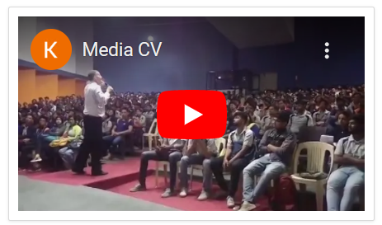
I have been in India for the last 24 years as missionary, 3 years getting fluent in the local Kannada language, 10 years as a travelling bible teacher 3 years as a pastor and 8 years as an evangelist. We could reach 1/3 million university students with the gospel in 1000 colleges (http://www.rescue108.com/records108).
We did 13 press meets, dozens of prime time TV programs on secular news channels, produced a few hundred newspaper articles and finally spoke to Indian central government securing the block of all pornography from the 4G mobile networks for the whole of India.
***My salvation and full ministry testimony: audio podcast: https://drive.google.com/file/d/1fNjJi-pxs5DJgG7qN6mpRjX6J7XI_zwl/view?usp=sharing *** :
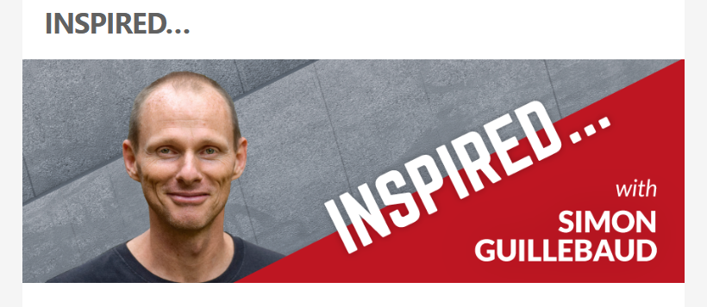
(This is the pre edited version, a few extra comments by the interviewer)
One of the ways I serve churches is helping them raise up salt and light teams:
To evangelize effectively and confront the darkness of our nations 1 to 1 and en masse from the lampstands in society, confronting the darkness of our generation and bringing about change: possible plan :
- Casting the vision Sunday morning and evening.
- 1 day Seminar on closing the gates of hell in the nation as salt and light, on masse pre evangelism, how to expose the destruction of contemporary evil ideologies connected with porn, trafficking, marriage, gender, abortion and evolution, how to access secular media, miracles in the media, turning a social issue into an evangelistic opportunity.
- Young adult evangelistic event or young people (15+) program for believers “The Ruining of Romance and the Poison of Pornography”
- Connect with local colleges / universities open to such programs
Books I have Written
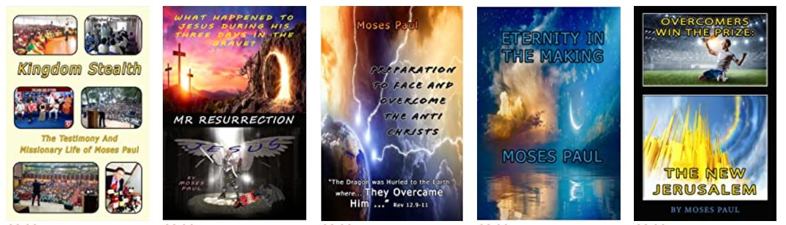
Amazon.co.uk: Moses Paul: Books, Biography, Blogs, Audiobooks, Kindle
Other Church Seminars:
- Hearing the voice of God and the Prophetic
- How to Have long effective 1-1 evangelistic conversations
- Eternity, the first day in heaven, and Reigning with Christ as a King
- Baptism in fire: the coming Revival

(I do not do children’s ministry: For youth programs 16-36! In India we did senior high school, degree and post grad).
A few photos of Indian ministry
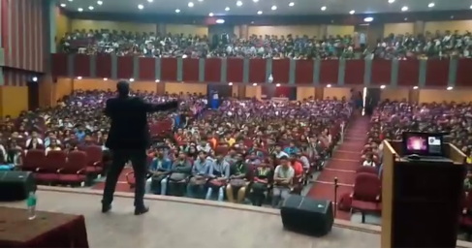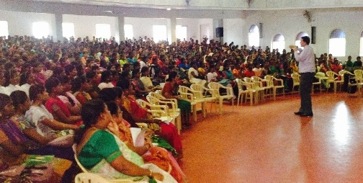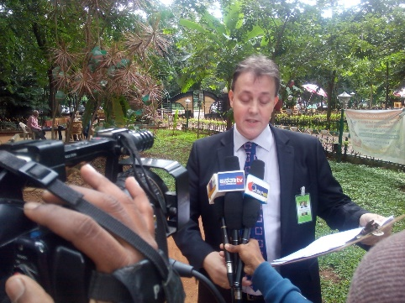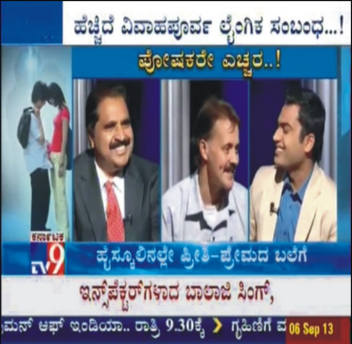
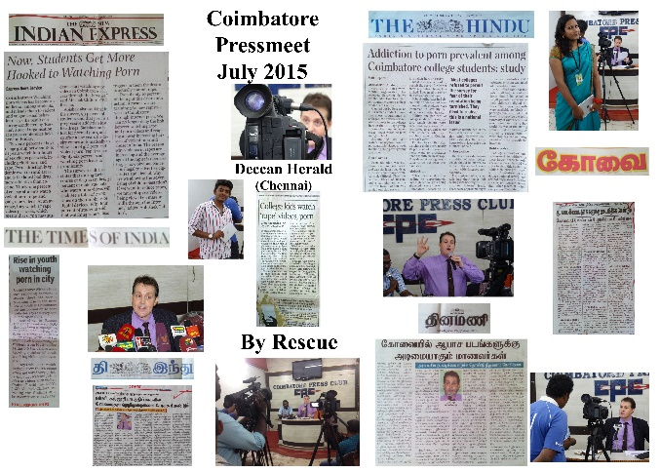
TV Programs
Christian:
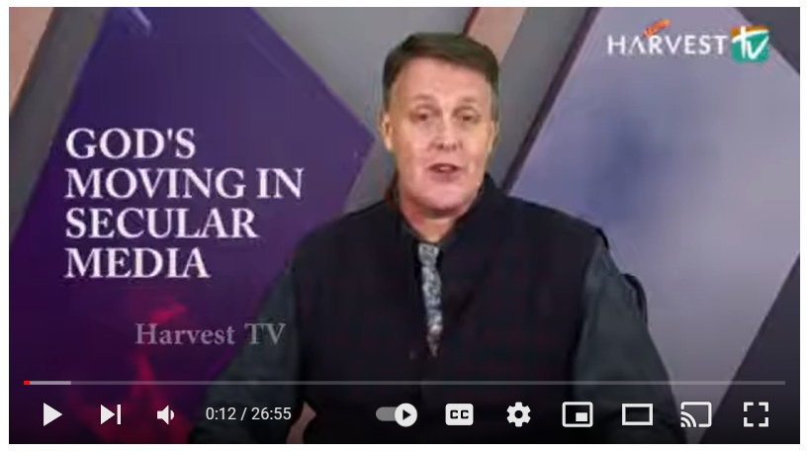
God`s Moving in Secular Media Epi 01 - YouTube
Secular: Media and TV - Rescue 108

We have this treasure in jars of clay!
Blessings , Hope I can encourage and inspire your church team!
Moses.

